Jenkins CI/CD Pipelines
Declarative · Scripted · Multi-Stage · Parallel

Objective
Using the source code at https://github.com/betawins/hiring-app.git, implement four separate Jenkins pipeline jobs, each demonstrating a distinct pipeline pattern:
- Job 1 — Declarative Pipeline: the standard, structured pipeline syntax.
- Job 2 — Scripted Pipeline: the older, fully-programmable Groovy syntax.
- Job 3 — Multi-Stage Pipeline: a realistic end-to-end CI/CD flow with several sequential stages.
- Job 4 — Parallel Stage Pipeline: multiple stages executing concurrently to reduce total build time.

Recommended Reading (Official Jenkins Documentation)
- Pipeline: https://www.jenkins.io/doc/book/pipeline/
- Environment Variables: https://www.jenkins.io/doc/book/pipeline/jenkinsfile/#using-environment-variables
- Parameters: https://www.jenkins.io/doc/book/pipeline/syntax/#parameters
- Handling Credentials in Pipeline: https://www.jenkins.io/doc/book/pipeline/jenkinsfile/#handling-credentials
Each concept from this reading list is deliberately exercised at least once across the four jobs below: environment variables in Jobs 1 and 3, parameters in Job 1, and credentials handling in Job 2.

Prerequisites
- A running Jenkins server with administrator access.
- A fork or direct access to push to https://github.com/betawins/hiring-app.git (each job's Jenkinsfile is committed to the repository, per Pipeline script from SCM).

One-Time Setup — Example Credential for Job 2
Job 2 demonstrates credentials handling using a placeholder secret. Create it once before running that job:
1. Manage Jenkins → Credentials → (global) → Add Credentials.
2. Kind: Secret text. Secret: demo-secret-value-12345 (a placeholder — substitute a real API key/token if this pipeline will call something that needs one).
3. ID: demo-api-key. Description: Example credential for Job 2's credentials-handling demo. Click Create.

Declarative Pipeline
Declarative Pipeline is the recommended, structured syntax for most Jenkins pipelines: a pipeline { } block containing well-defined sections (agent, parameters, environment, stages, post), validated up front before anything runs. This job demonstrates parameters and environment variables together, per the official documentation linked above.

Step 1 — Add the Jenkinsfile to the Repository
In your local clone of hiring-app, create Jenkinsfile.declarative at the repository root:
pipeline {
agent any
parameters {
choice(name: 'ENVIRONMENT', choices: ['dev', 'staging', 'prod'],
description: 'Target deployment environment')
booleanParam(name: 'RUN_TESTS', defaultValue: true,
description: 'Run the unit test stage?')
}
environment {
APP_NAME = 'hiring-app'
BUILD_ENV = "${params.ENVIRONMENT}"
}
stages {
stage('Checkout') {
steps {
echo "Cloning ${APP_NAME} for environment: ${BUILD_ENV}"
git branch: 'main',
url: ' https://github.com/swaroop706-design/hiring-app.git '
}
}
stage('Build') {
steps {
echo "Building ${APP_NAME} for ${BUILD_ENV}..."
sh 'ls -la'
// Replace with the real build command for this project,
// e.g. 'npm ci && npm run build' or 'mvn -B package'
}
}
stage('Test') {
when {
expression { return params.RUN_TESTS }
}
steps {
echo 'Running unit tests...'
sh 'echo "(placeholder) test command goes here"'
}
}
}
post {
always {
echo "Pipeline finished for ${APP_NAME} — environment: ${BUILD_ENV}, tests run: ${params.RUN_TESTS}"
}
}
}
2. Commit and push it:
git add Jenkinsfile.declarative
git commit -m "Add declarative pipeline"
git push origin main

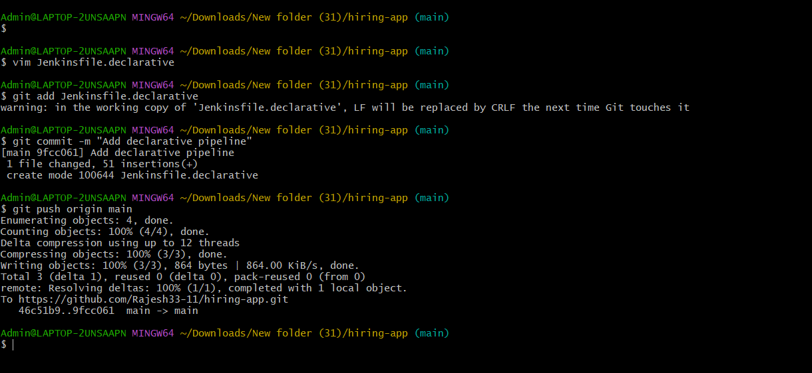

Step 1.2 — Create the Job
1. Jenkins Dashboard → New Item. Item name: HiringApp-Declarative. Type: Pipeline → OK.
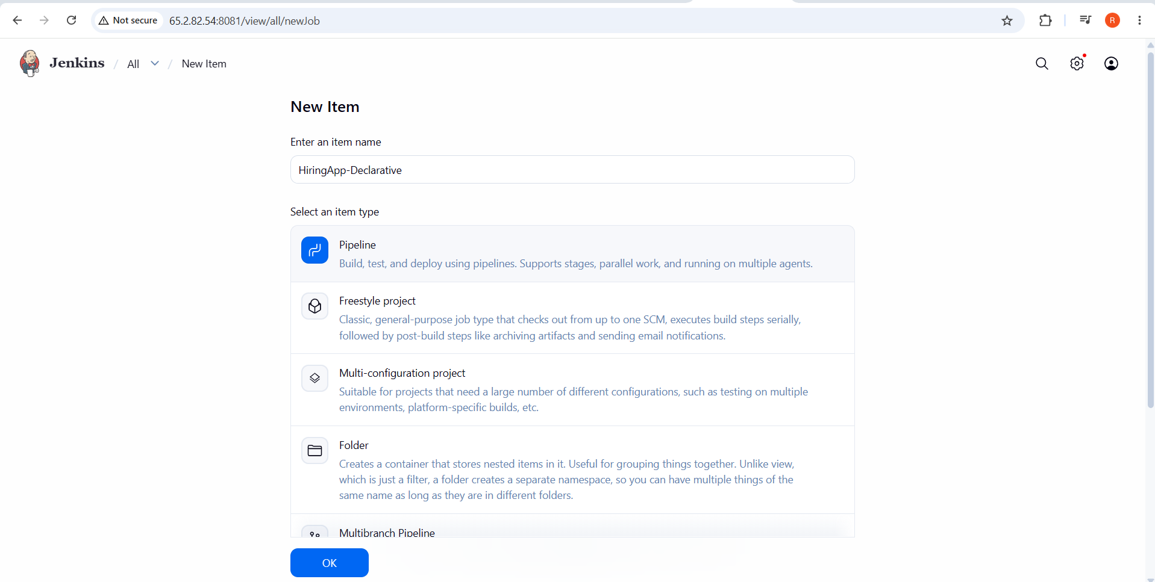
2. Under Pipeline, Definition: Pipeline script from SCM. SCM: Git.
3. Repository URL: https://github.com/betawins/hiring-app.git. Branch Specifier: */main.
4. Script Path: Jenkinsfile.declarative (not the default Jenkinsfile).
5. Click Save.

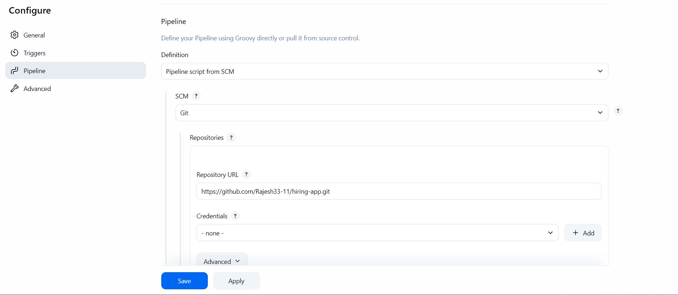

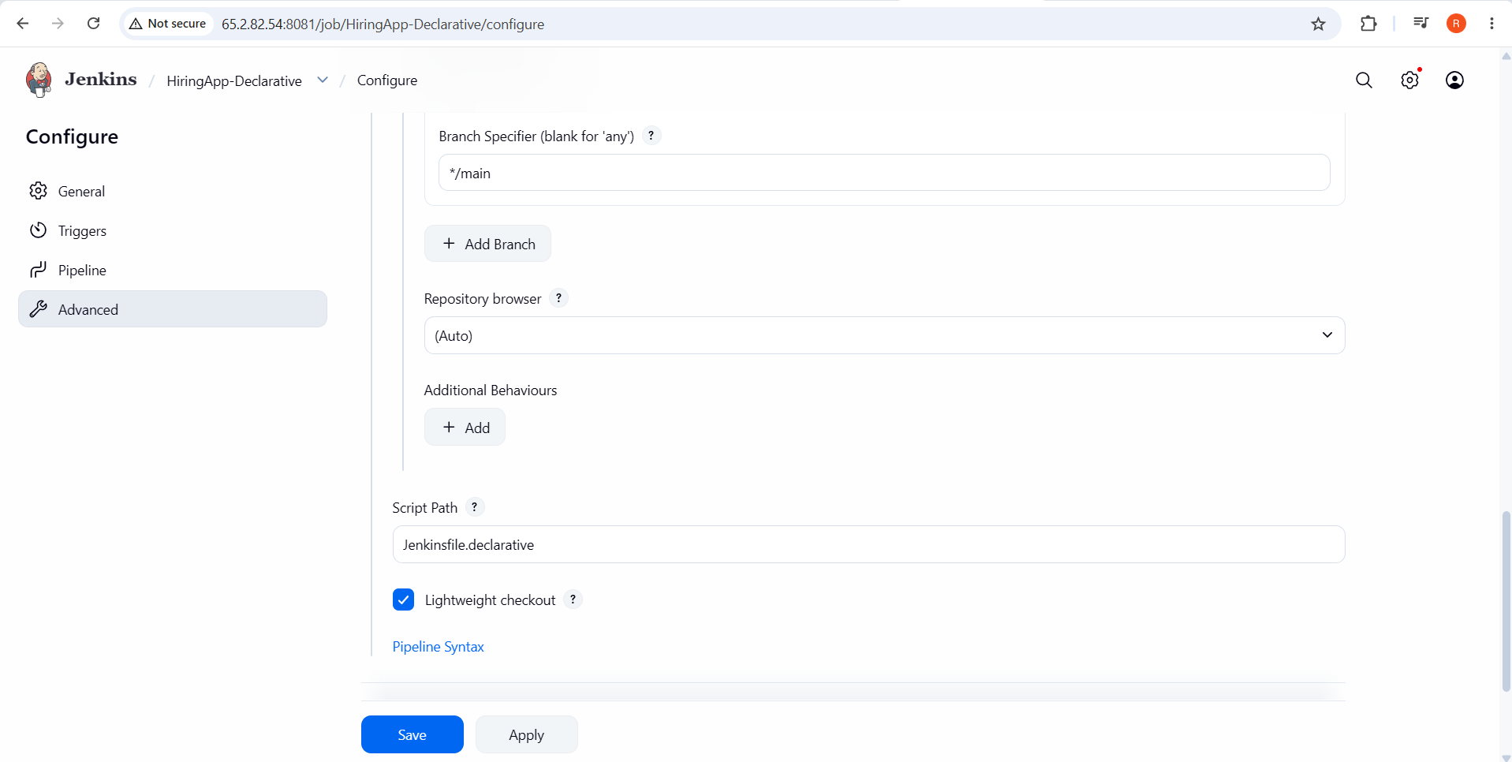

Step3 — Run and Verify
1. Click Build with Parameters (this option appears automatically once Jenkins has read the parameters block on a first scan/run).
2. Select ENVIRONMENT: staging, leave RUN_TESTS checked → Build.
3. Open the build's Console Output and confirm the Checkout, Build, and Test stages all ran, and that Building hiring-app for staging... appears — confirming both the parameter and the environment variable derived from it flowed through correctly.
4. Run it again with RUN_TESTS unchecked, and confirm the Test stage is now skipped (Stage "Test" skipped due to when conditional) rather than executed.
✅ Job 1 Complete: HiringApp-Declarative demonstrates a standard declarative pipeline using both a parameters block and an environment block, with a when condition gating a stage on a parameter's value.
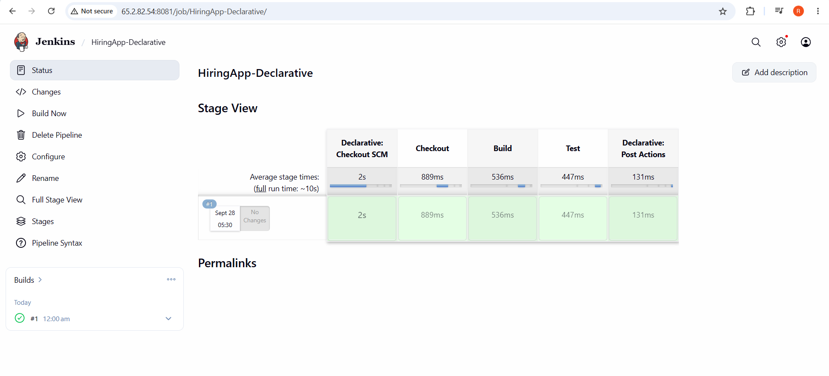
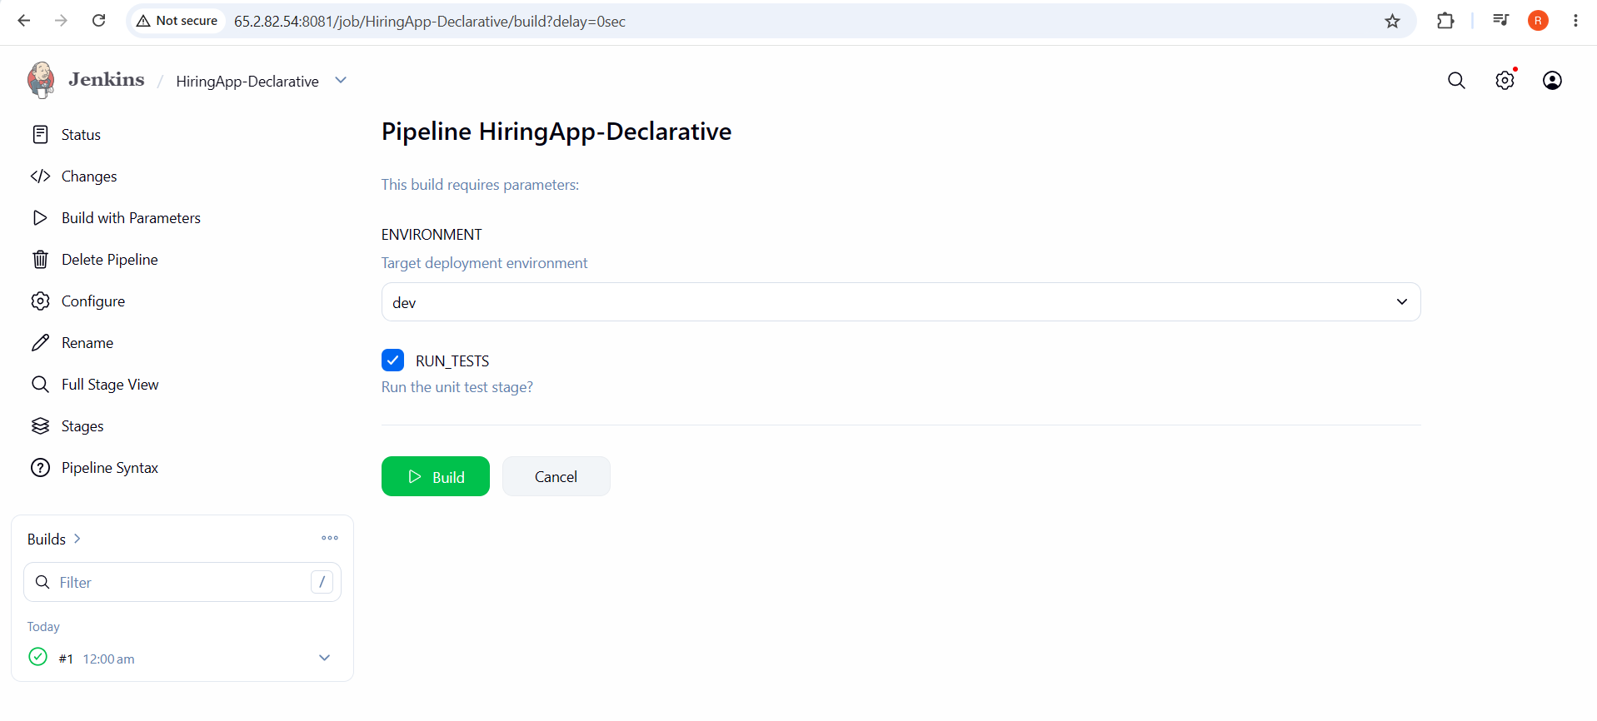
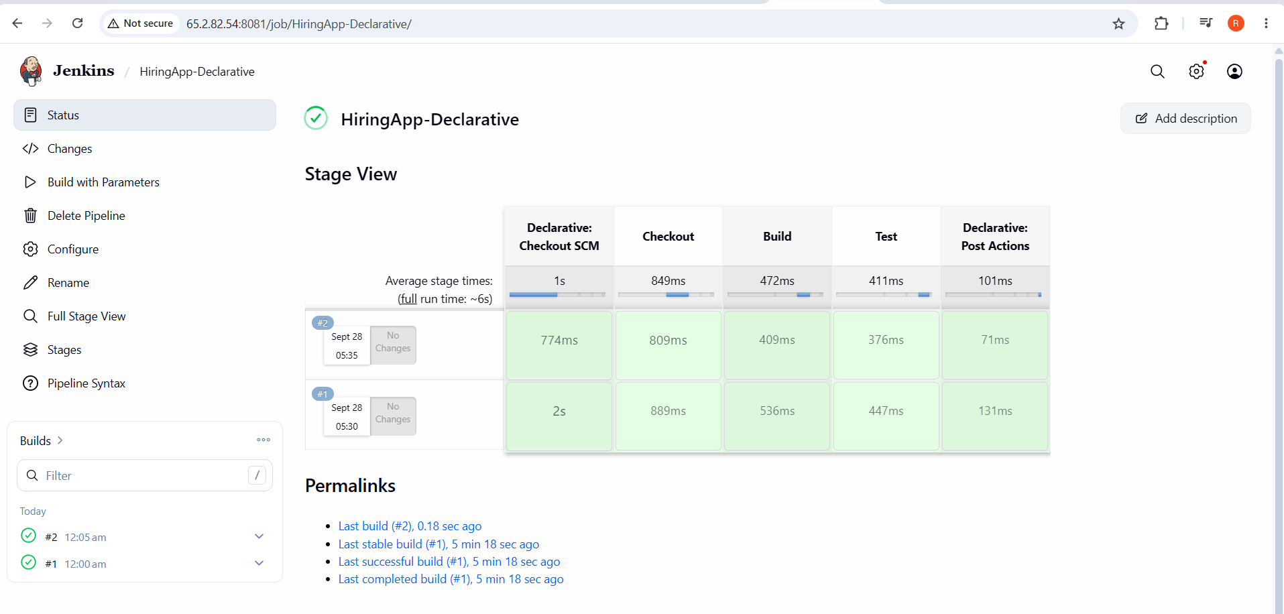

Scripted Pipeline
Scripted Pipeline uses raw Groovy inside a node { } block instead of the declarative sections — more verbose, but fully programmable (loops, try/catch, arbitrary conditionals) since it has none of Declarative's up-front structure validation. This job demonstrates that flexibility, plus secure credentials handling.

Step 1 — Add the Jenkinsfile to the Repository
1. Create Jenkinsfile.scripted at the repository root:
node {
def appName = 'hiring-app'
def modules = ['auth', 'jobs', 'candidates']
try {
stage('Checkout') {
echo "Cloning ${appName}..."
git branch: 'main', url: ' https://github.com/swaroop706-design/hiring-app.git '
}
stage('Build') {
echo "Building ${appName}..."
sh 'ls -la'
}
stage('Use a Credential Securely') {
withCredentials([string(credentialsId: 'demo-api-key', variable: 'API_KEY')]) {
// Single-quoted Groovy string: $API_KEY is expanded by the SHELL,
// never by Groovy — this is what lets Jenkins mask the secret
// in the console log. Never use a double-quoted "${API_KEY}" here.
sh 'echo "Credential loaded, length: ${#API_KEY} characters"'
}
}
stage('Validate Modules (loop example)') {
for (m in modules) {
echo "Validating module: ${m}"
}
}
} catch (Exception e) {
echo "Pipeline failed: ${e.getMessage()}"
currentBuild.result = 'FAILURE'
throw e
} finally {
stage('Cleanup') {
echo 'Cleaning workspace...'
deleteDir()
}
}
}
2. Commit and push it:
git add Jenkinsfile.scripted
git commit -m "Add scripted pipeline"
git push origin main

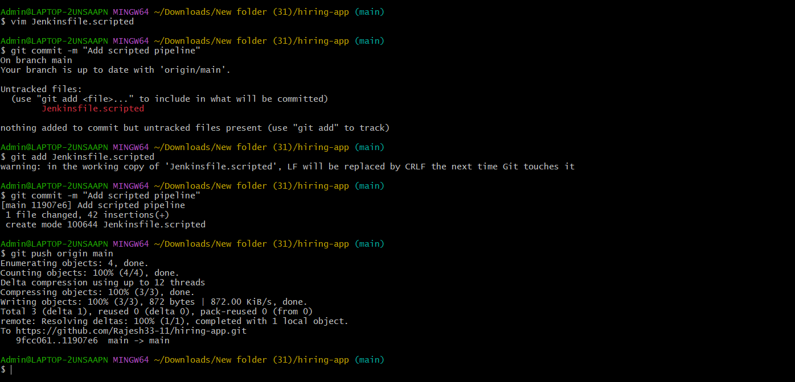

Step 2 — Create the Job
1. Dashboard → New Item. Item name: HiringApp-Scripted. Type: Pipeline → OK.
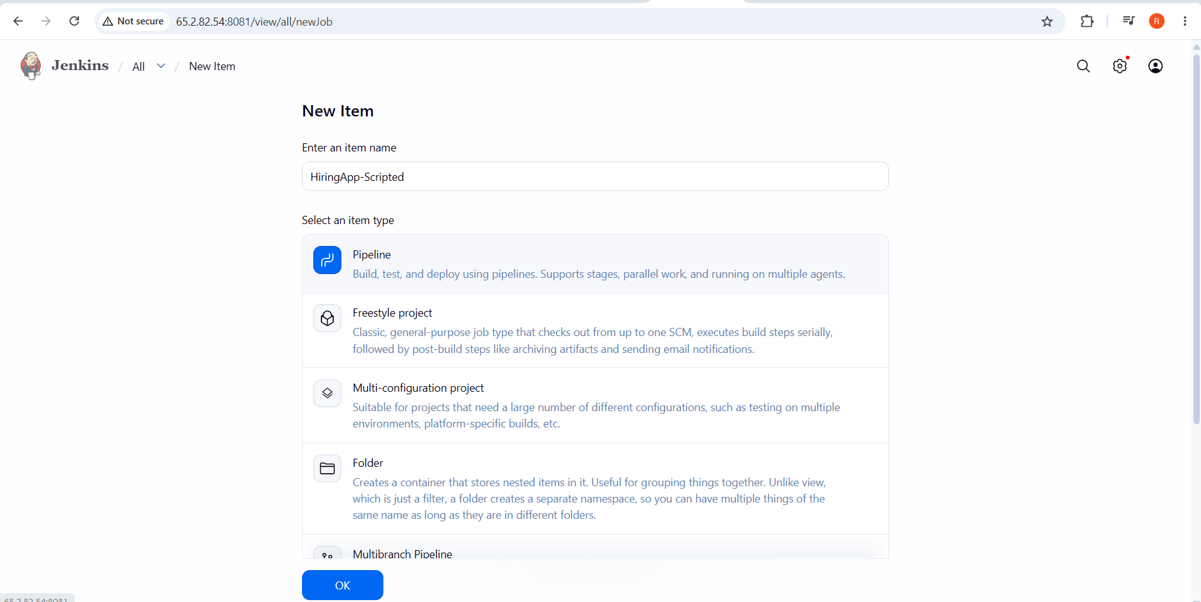
2. Pipeline → Definition: Pipeline script from SCM → Git → Repository URL: https://github.com/betawins/hiring-app.git → Branch: */main.
3. Script Path: Jenkinsfile.scripted → Save.

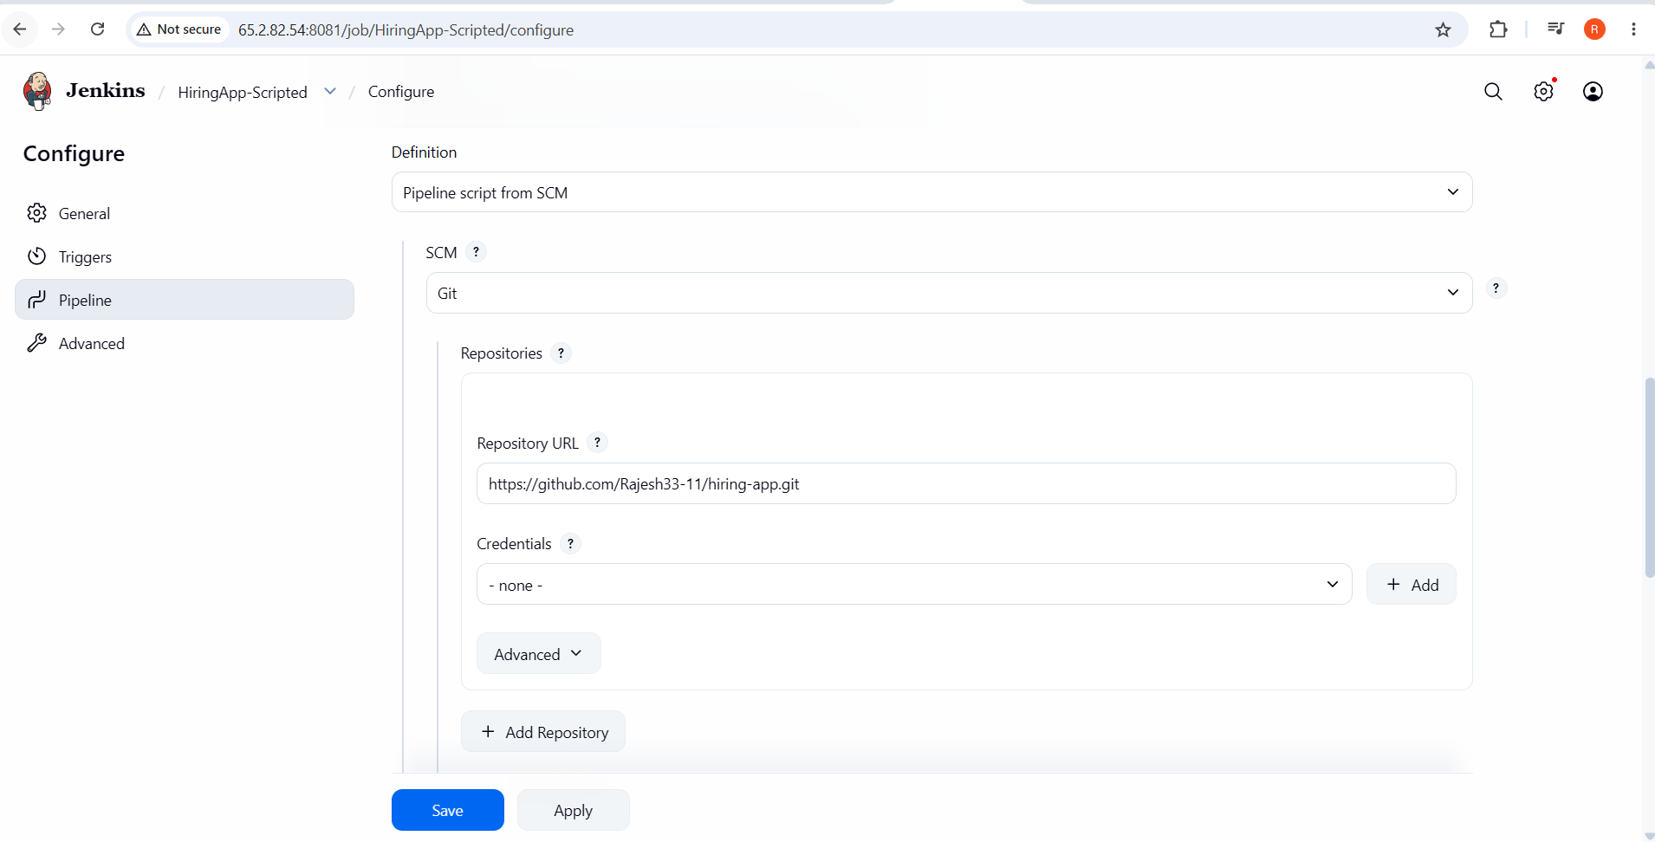

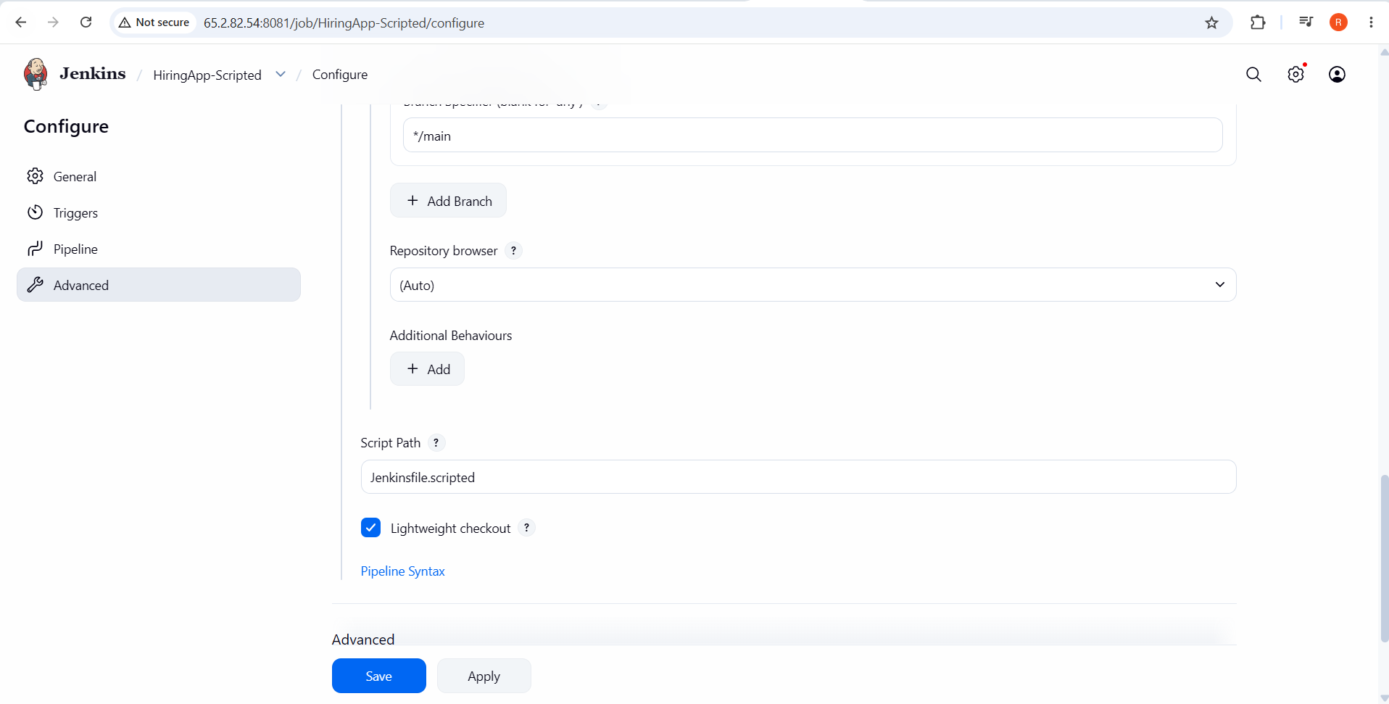

Step 3 — Run and Verify
1. Click Build Now → open the build → Console Output.
2. Confirm all four stages run: Checkout, Build, Use a Credential Securely, Validate Modules, plus Cleanup in the finally block.
3. In the Use a Credential Securely stage's output, confirm the log shows Credential loaded, length: NN characters — and, critically, that the actual secret value demo-secret-value-12345 never appears anywhere in the log (Jenkins replaces any literal occurrence of a bound credential's value with **** automatically).
4. Confirm the Validate Modules stage prints all three module names from the Groovy for loop — something a pure Declarative pipeline cannot do without dropping into a script { } block.
✅ Job 2 Complete: HiringApp-Scripted demonstrates Scripted Pipeline's programmatic control (try/catch/finally, a for loop) and secure credential handling via withCredentials with proper single-quoted shell interpolation.
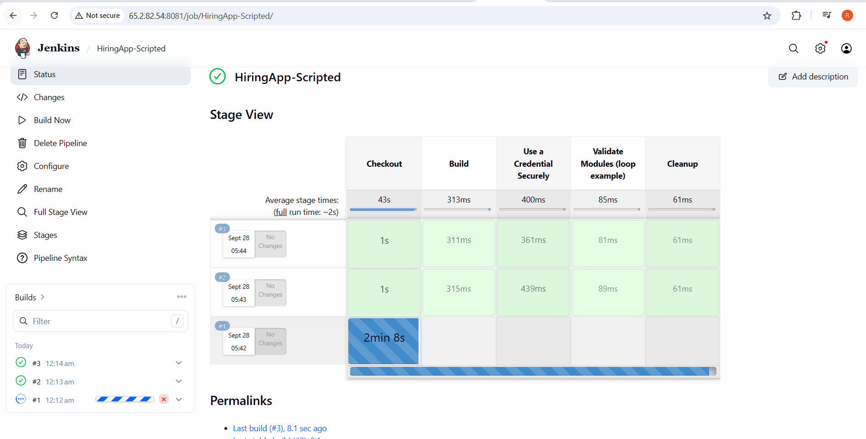

Multi-Stage Pipeline
This job models a realistic end-to-end CI/CD flow for hiring-app: a longer sequence of Declarative stages representing what a production pipeline typically looks like, from checkout through to a post-deployment check.

Step 1 — Add the Jenkinsfile to the Repository
1. Create Jenkinsfile.multistage at the repository root:
pipeline {
agent any
environment {
APP_NAME = 'hiring-app'
DEPLOY_DIR = '/opt/hiring-app-deploy'
}
stages {
stage('Checkout') {
steps {
echo "Cloning ${APP_NAME}..."
git branch: 'main', url: ' https://github.com/swaroop706-design/hiring-app.git '
}
}
stage('Build') {
steps {
echo 'Building application...'
sh 'ls -la'
// e.g. 'npm ci && npm run build' or 'mvn -B compile'
}
}
stage('Unit Test') {
steps {
echo 'Running unit tests...'
sh 'echo "(placeholder) unit test command"'
}
}
stage('Code Quality Check') {
steps {
echo 'Running static analysis...'
sh 'echo "(placeholder) lint/SonarQube step"'
}
}
stage('Package') {
steps {
echo 'Packaging build artifact...'
sh 'tar -czf ${APP_NAME}-${BUILD_NUMBER}.tar.gz --exclude=.git .'
archiveArtifacts artifacts: "${APP_NAME}-${BUILD_NUMBER}.tar.gz", fingerprint: true
}
}
stage('Deploy to Staging') {
steps {
echo "Deploying ${APP_NAME} build #${BUILD_NUMBER} to staging..."
sh 'echo "(placeholder) copy artifact to staging host / run deploy script"'
}
}
stage('Smoke Test') {
steps {
echo 'Running post-deployment smoke test...'
sh 'echo "(placeholder) curl the staging health-check endpoint"'
}
}
}
post {
success {
echo "Pipeline succeeded: ${APP_NAME} build #${BUILD_NUMBER} deployed to staging."
}
failure {
echo "Pipeline failed at some stage for ${APP_NAME} build #${BUILD_NUMBER}."
}
}
}
2. Commit and push it:
git add Jenkinsfile.multistage
git commit -m "Add multi-stage pipeline"
git push origin main

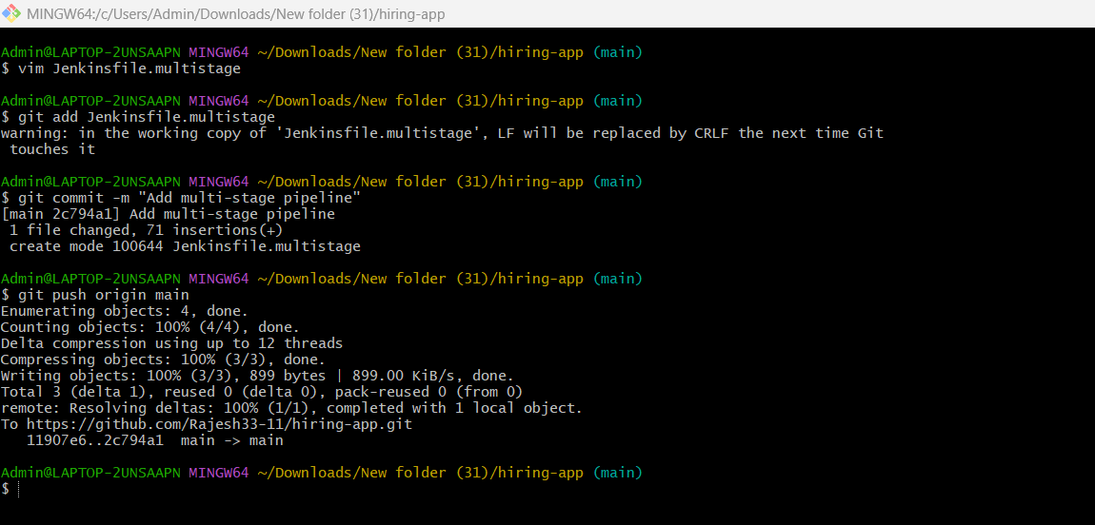

Step 2 — Create the Job
1. Dashboard → New Item. Item name: HiringApp-MultiStage. Type: Pipeline → OK.
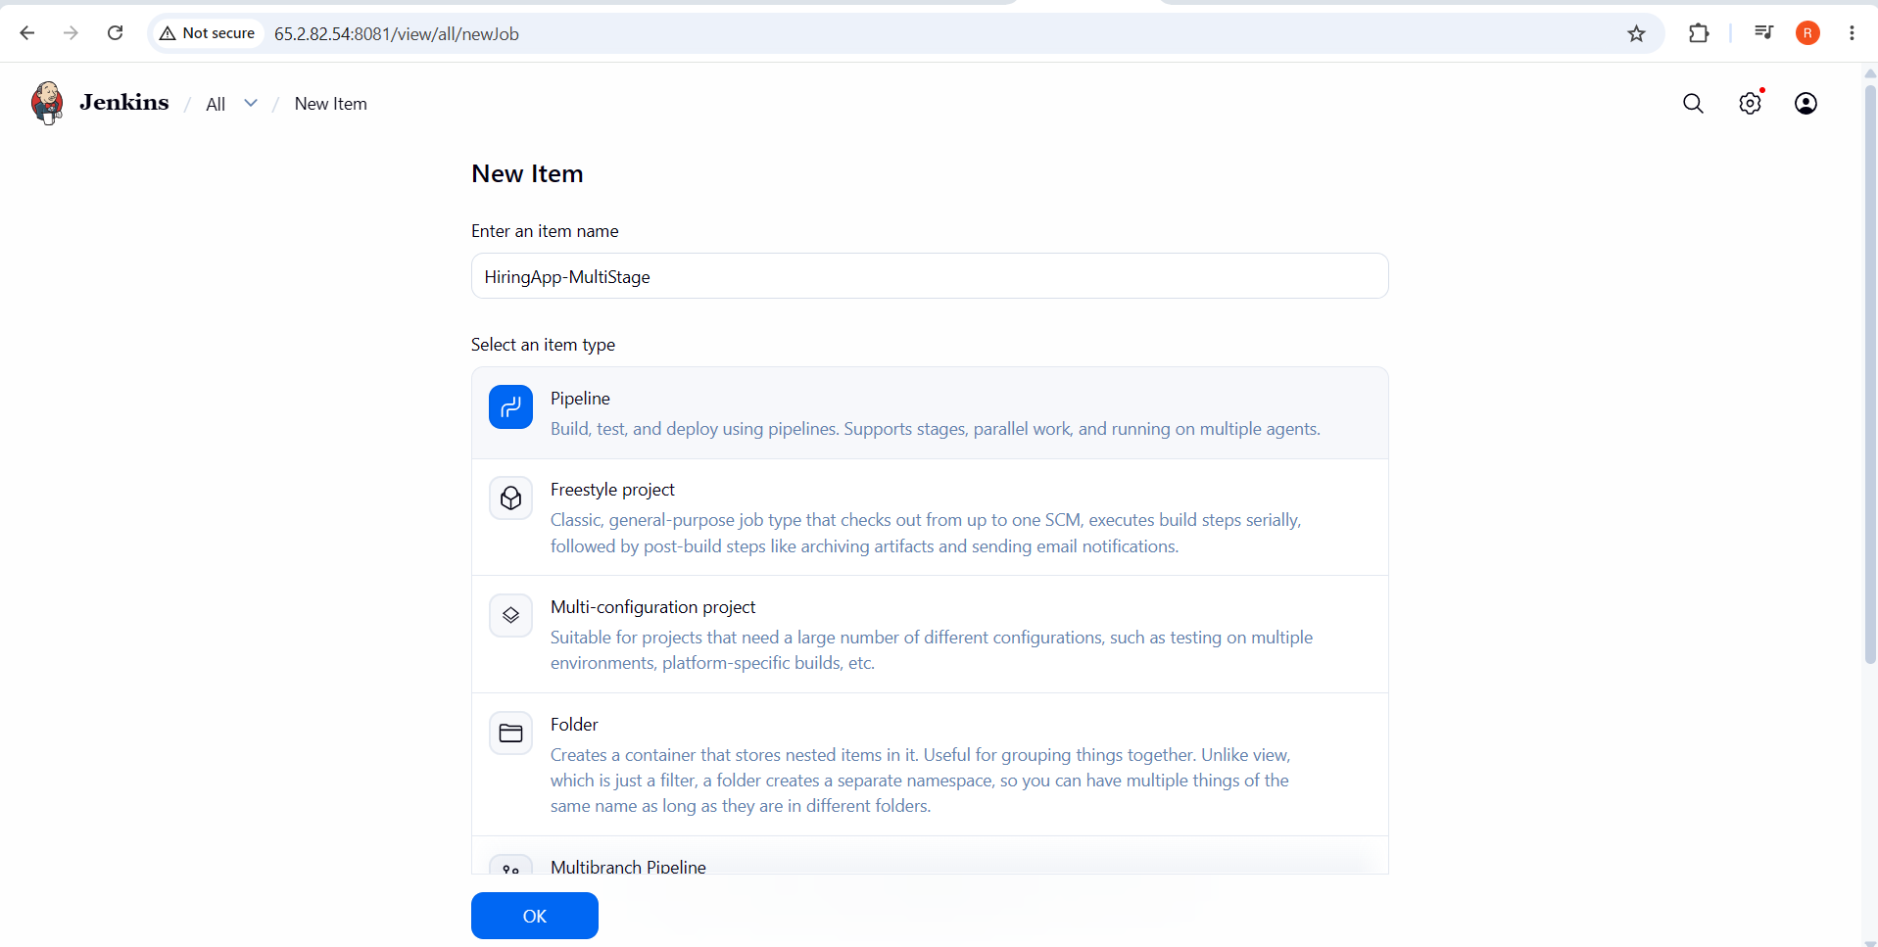
2. Pipeline → Definition: Pipeline script from SCM → Git → Repository URL: https://github.com/betawins/hiring-app.git → Branch: */main.
3. Script Path: Jenkinsfile.multistage → Save.

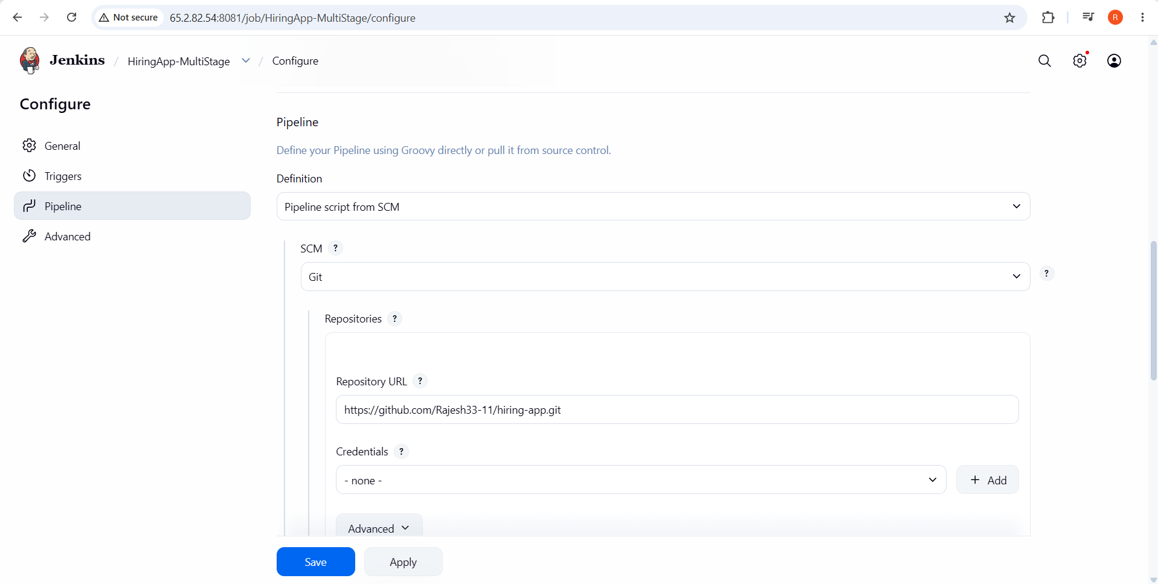

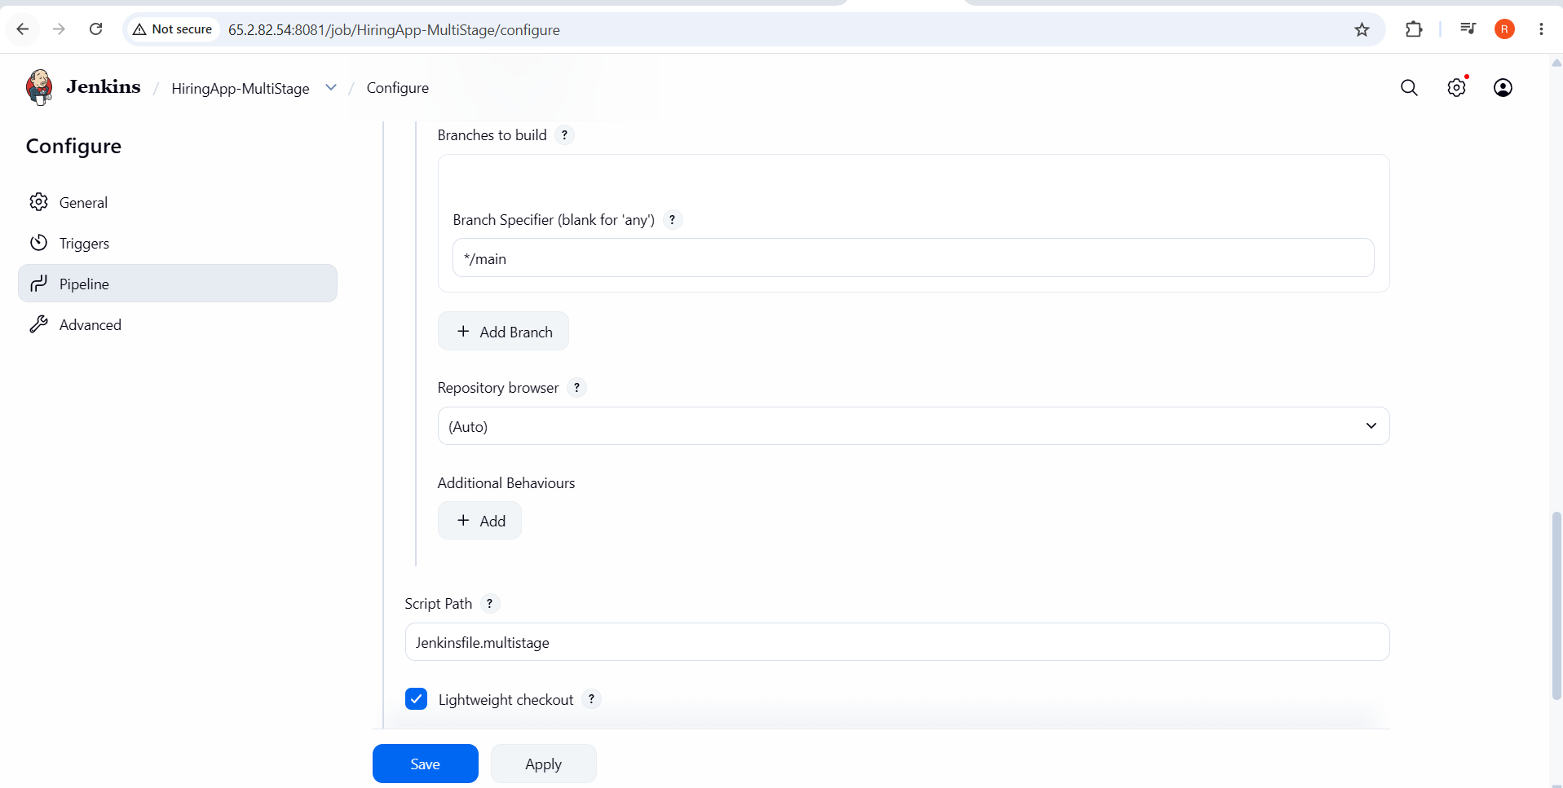

Step 3 — Run and Verify
1. Click Build Now → open the build → confirm the Stage View shows all seven stages in order: Checkout, Build, Unit Test, Code Quality Check, Package, Deploy to Staging, Smoke Test.
2. Open the build page → confirm an archived artifact named hiring-app-<build-number>.tar.gz is listed and downloadable.
3. Confirm the Console Output ends with the post { success { ... } } message.
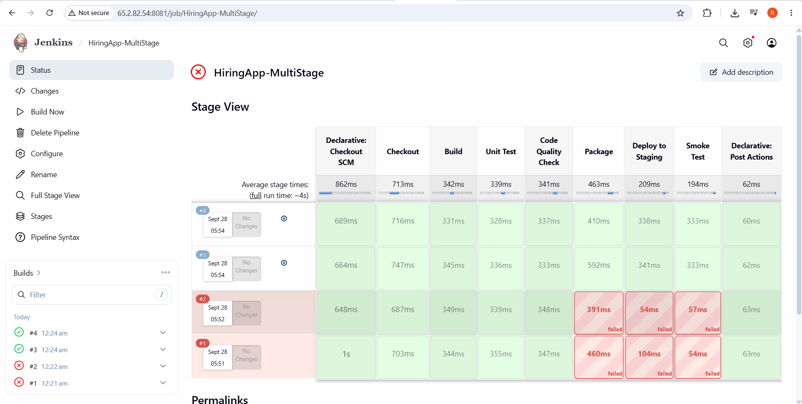
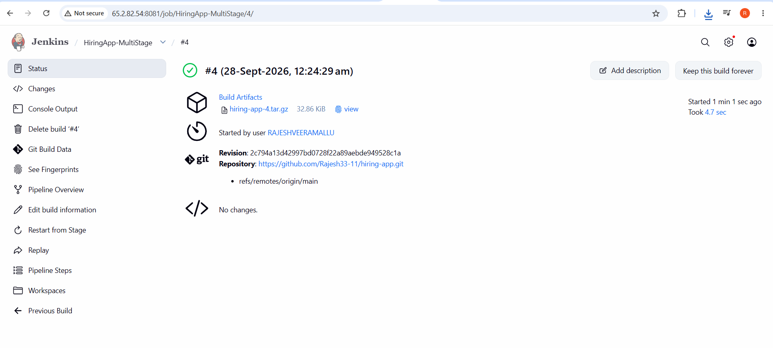

Parallel Stage Pipeline
This job takes three of the independent verification steps from Job 3 (unit tests, lint/code-quality, and a security scan) and runs them concurrently inside a single parallel stage, then only proceeds to packaging once all three finish — reducing total pipeline duration compared to running them one after another.

Step 1 — Add the Jenkinsfile to the Repository
1. Create Jenkinsfile.parallel at the repository root:
pipeline {
agent any
environment {
APP_NAME = 'hiring-app'
}
stages {
stage('Checkout') {
steps {
echo "Cloning ${APP_NAME}..."
git branch: 'main', url: 'https://github.com/Swaroop706-design/hiring-app.git'
}
}
stage('Build') {
steps {
echo 'Building application...'
sh 'ls -la'
}
}
stage('Quality Gates (parallel)') {
parallel {
stage('Unit Tests') {
steps {
echo 'Running unit tests...'
sh 'sleep 5; echo "(placeholder) unit test command"'
}
}
stage('Lint') {
steps {
echo 'Running linter...'
sh 'sleep 5; echo "(placeholder) lint command"'
}
}
stage('Security Scan') {
steps {
echo 'Running dependency/security scan...'
sh 'sleep 5; echo "(placeholder) security scan command"'
}
}
}
}
stage('Package') {
steps {
echo 'All quality gates passed — packaging build artifact...'
sh 'tar -czf ${APP_NAME}-${BUILD_NUMBER}.tar.gz --exclude=.git .'
archiveArtifacts artifacts: "${APP_NAME}-${BUILD_NUMBER}.tar.gz", fingerprint: true
}
}
}
post {
always {
echo "Pipeline finished for ${APP_NAME} build #${BUILD_NUMBER}."
}
}
}
2. Commit and push it:
git add Jenkinsfile.parallel
git commit -m "Add parallel-stage pipeline"
git push origin main

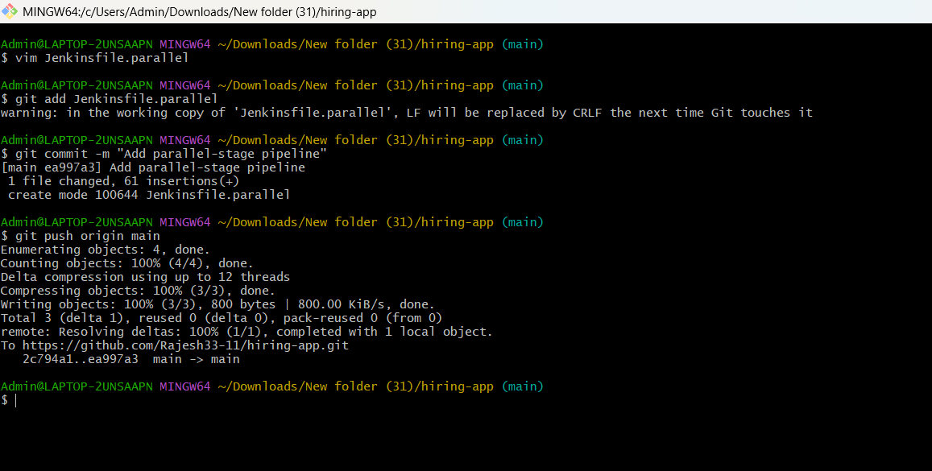

Step 2 — Create the Job
1. Dashboard → New Item. Item name: HiringApp-Parallel. Type: Pipeline → OK.
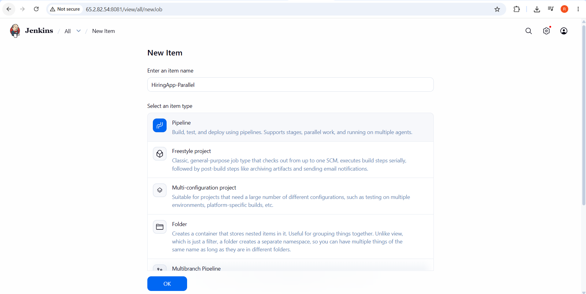
2. Pipeline → Definition: Pipeline script from SCM → Git → Repository URL: https://github.com/betawins/hiring-app.git → Branch: */main.
3. Script Path: Jenkinsfile.parallel → Save.

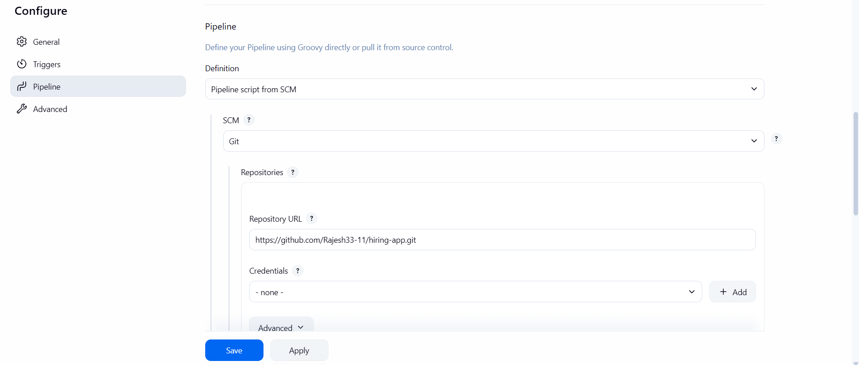

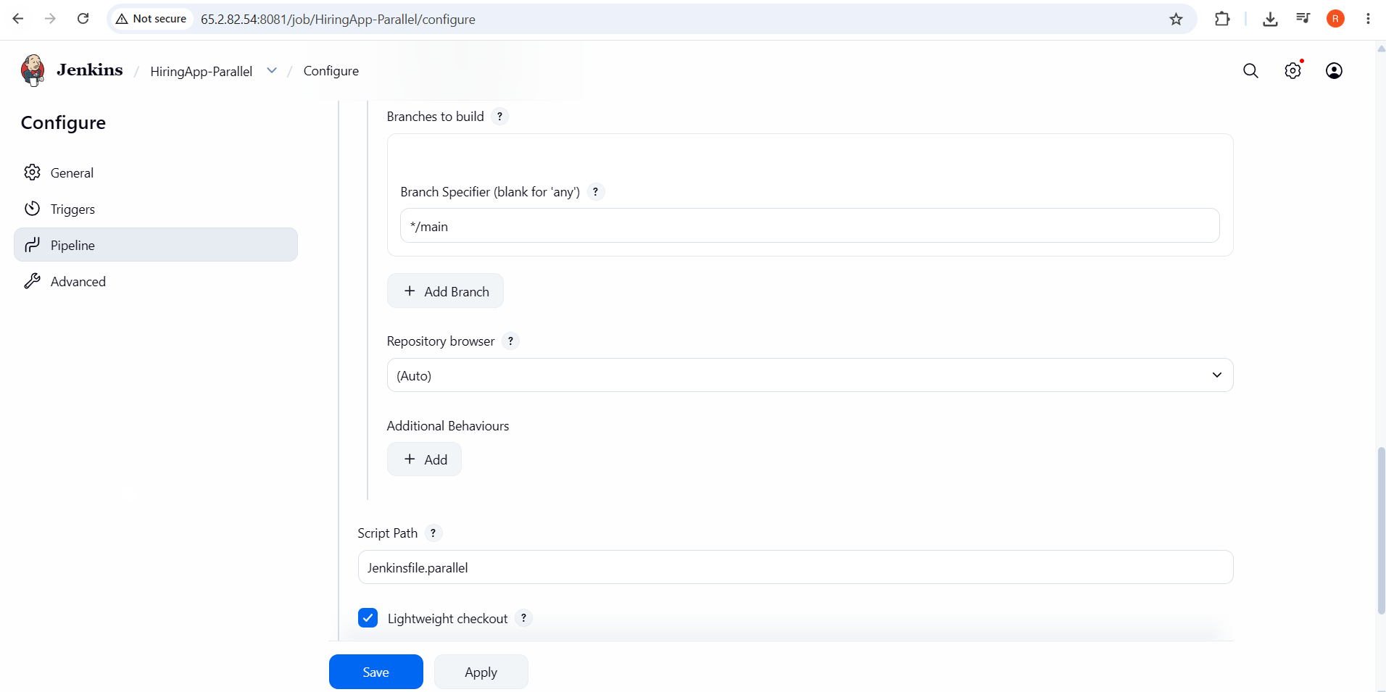

Step 3 — Run and Verify
1. Click Build Now → open the build → click Stage View (or Blue Ocean, if installed) and confirm Unit Tests, Lint, and Security Scan are drawn side by side under Quality Gates (parallel), not one after another.
2. Check the total elapsed time for the Quality Gates (parallel) stage in Console Output/timestamps — confirm it is close to 5 seconds (the longest single branch's sleep 5), not roughly 15 seconds (the sum of all three), proving they genuinely ran concurrently rather than sequentially.
3. Confirm the Package stage only starts after all three parallel branches complete, and that its artifact is archived successfully, exactly as in Job 3.
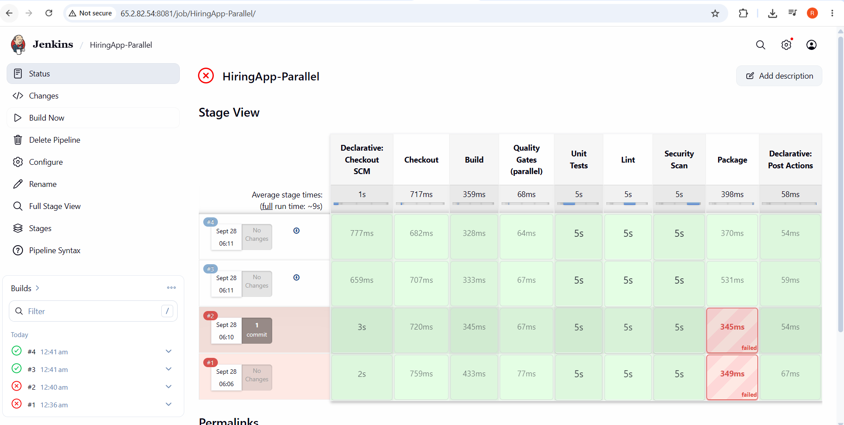
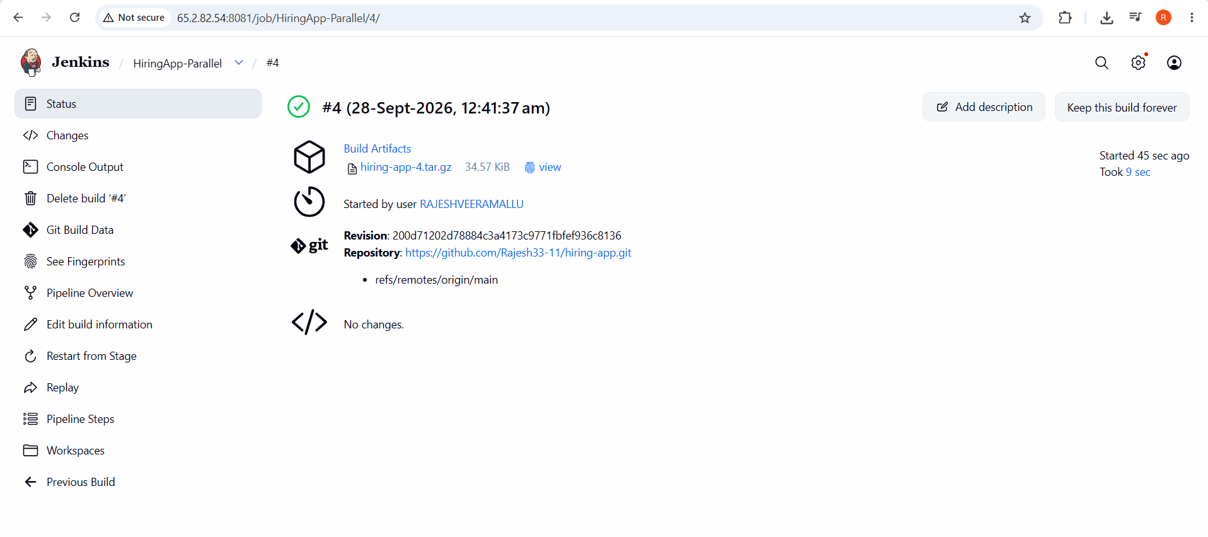

Job | Jenkinsfile | Pattern Demonstrated | Doc Concept Used
HiringApp-Declarative | Jenkinsfile.declarative | Structured Declarative syntax | Parameters + Environment Variables
HiringApp-Scripted | Jenkinsfile.scripted | Imperative Groovy (loop, try/catch/finally) | Handling Credentials
HiringApp-MultiStage | Jenkinsfile.multistage | 7-stage realistic CI/CD flow with an archived artifact | Environment Variables
HiringApp-Parallel | Jenkinsfile.parallel | Concurrent stages inside one parallel block | Pipeline syntax (parallel)

